AD
Please Note for Each OS, you will need to show how you installed it, and you are required to do updates.
- Install Active Directory
- Promote the Directory by configuring it

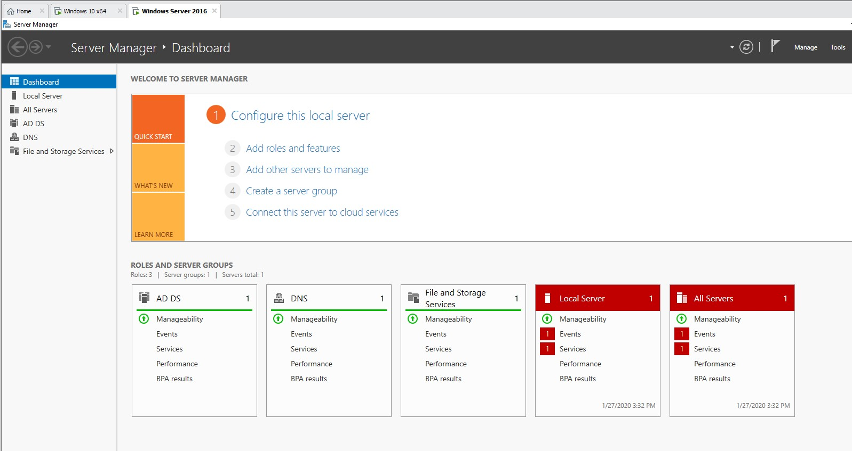
- Create 6 user accounts
  - Take note of the users and the passwords
User1,2,3,4,5,6 -------- Password - Userlocal1@
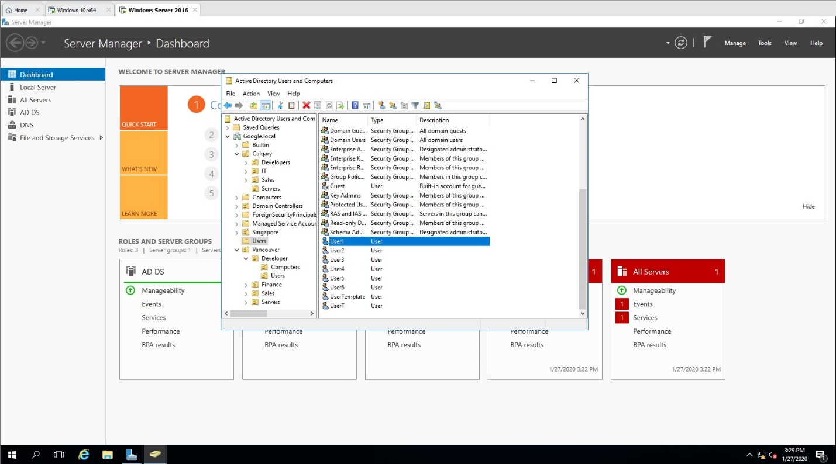

- The company has offices in Vancouver, Calgary, and Singapore. In Vancouver you have developers, finance, and sales, in Calgary you have developers, IT, and Sales, and Singapore you have Sales team. Note that each site will have a server assigned to it, and workstation
  - Ensure you configure your AD OU according


- Install one workstations, and join them to the domain
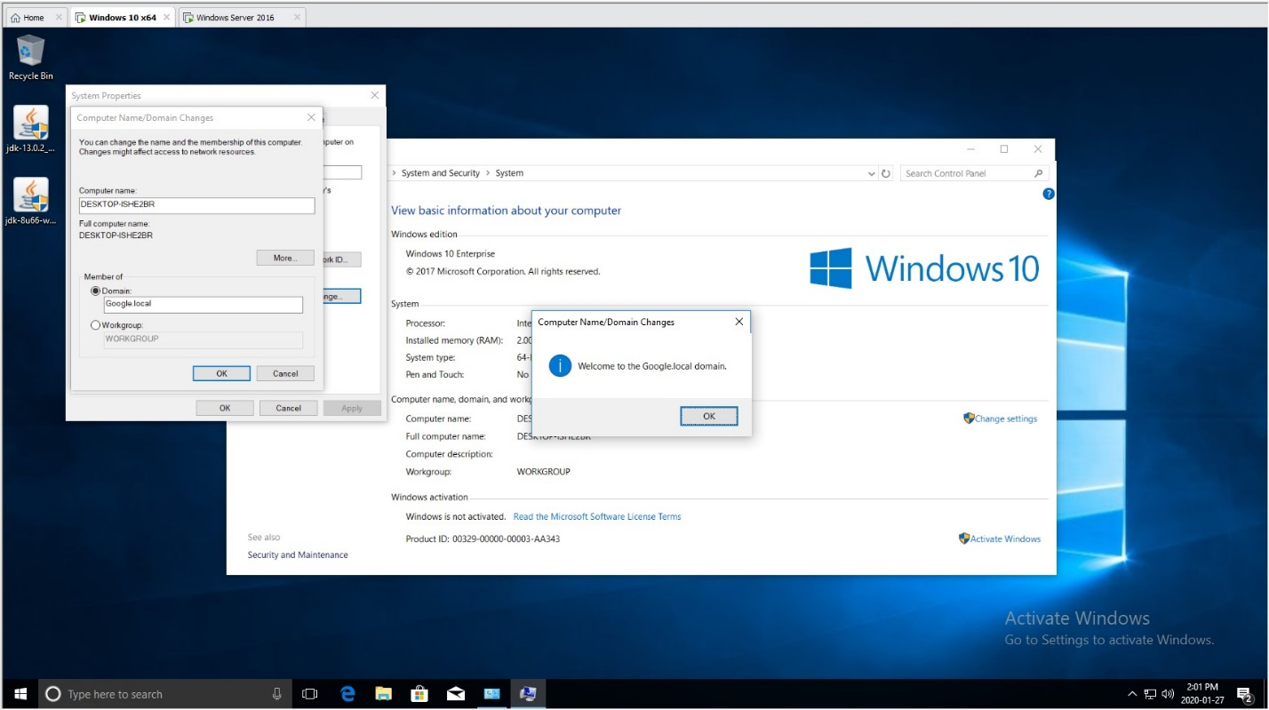
- Create a user account template to standardize setup
  - Create a user using this template
- Reset user account password
- Unlock user account
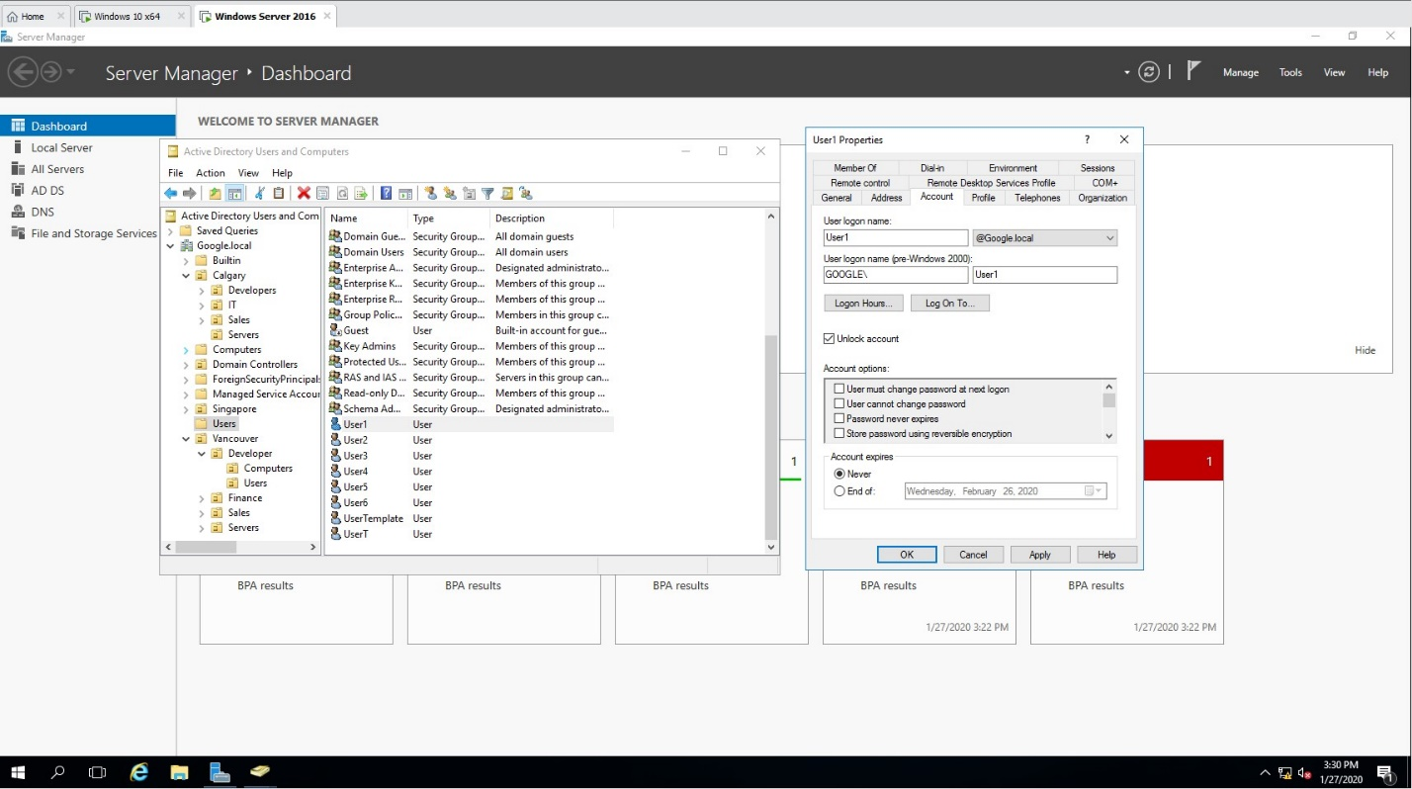
- Modify user account by allowing one user to have remote access to the Server (Note this user needs to be a domain admin)
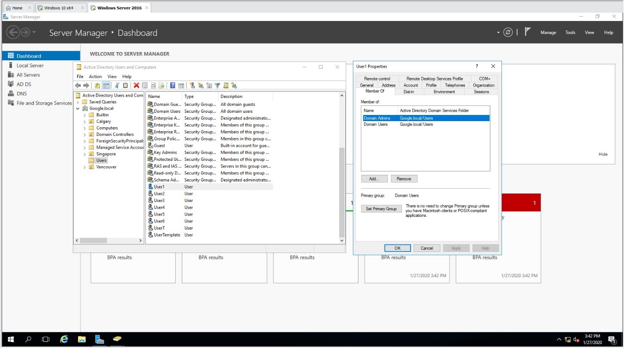

- Ensure your non admin user can log in to the workstation
